
CENSUS SOLUTIONS WORKSHOP TOOLKIT

T
A guide to running creative and collaborative workshops to foster new partnerships and solve census challenges in your community


PRE-DECISIONAL DOCUMENT FOR REFERENCE ONLY, NOT FOR DISTRIBUTION

1— OVERVIEW

What is a Census Solutions Workshop?

3 | What, who & why
4 | How to use this toolkit
5 | The origin of this toolkit
6 | What a workshop looks like
13 | How to run a workshop
14 | Benefits of a Census Solutions Workshop
15 | The format
16 | Census 101

WHATTHIS IS

WHO IT'S FOR

WHY IT MATTERS
A solutions workshop is a creative, collaborative, problem-solving event that brings together diverse thinkers.
The Census Solutions Workshop is specifically geared to generate new ways of communicating the importance of census data, reaching hard-to-count populations, and encouraging participation in Census Bureau surveys and programs.

We designed this toolkit for any organization, company, or community group invested in getting out the count— and seeking creative collaborations and new ideas for doing so.

A complete count ensures accurate census data that is critical for government programs, policies, and decision-making, but participation in Census Bureau surveys has declined in recent decades.
The workshop consists of a specific series of activities based on a design thinking methodology that help participants get to know each other, set ambitious goals, think outside the box, brainstorm with others, and quickly develop proposals for new solutions to engage communities in the census.
This toolkit is a step-by-step guide to planning and running a successful Census Solutions Workshop.

The Census Bureau has always relied on partners like you to help spread the word. We want to support you in coming up with innovative and engaging ways to reach your communities.

The Census Solutions Workshop Toolkit is split into five chapters. These parts are individually downloadable and distributable. Go through them in order or skip to the section you need most.

1 OVERVIEW
Why host a Census Solutions Workshop: What it looks like, why it matters and who benefits from it

How to host a Census Solutions Workshop: Roles and responsibilities, planning time- line, checklists, and what to keep in mind
2 LOGISTICS

ACTIVITIES
- CASE STUDIES
- RESOURCES
What to do at a Census Solutions Work- shop: Sample agendas, step-by-step guide to the activities suggested

What we’ve learned from hosting Census Solutions Workshops: Lessons from pilot workshops

Tools and materials you can use at your Census Solutions Workshop: worksheets, checklists, and printable handouts

At the U.S. Census Bureau, we rely on the support of partners across the country in collecting the data that will inform federal funding, representation, and redistricting. Your community trusts you—help them understand the value of census data and why they should participate in surveys.

The innovation team at the Census Bureau saw an opportunity to help you do this critically important work. We designed, tested, and refined a collaborative workshop that brings diverse thinkers together to generate new ideas for outreach, develop unexpected partnerships, and ultimately commit to taking action.
For example, some ideas that have resulted
from workshops include:
- a neighbor-to-neighbor toolkit for get- ting the Census word out
- a toolkit + campaign to engage local libraries in Census count, focusing on persons experiencing homelessness (PEH)
- a teen Census Ambassador program
- a Census ‘Get Out The Count’ campaign
block-party for local activation
These workshops can occur anywhere in a variety of formats, with any area of focus that serves the needs of your community. Anyone wanting to engage in census efforts can take part—whether they be a company, a community-based organization, a city official, and so on.
This toolkit is a step-by-step guide to
planning and running a workshop like this.

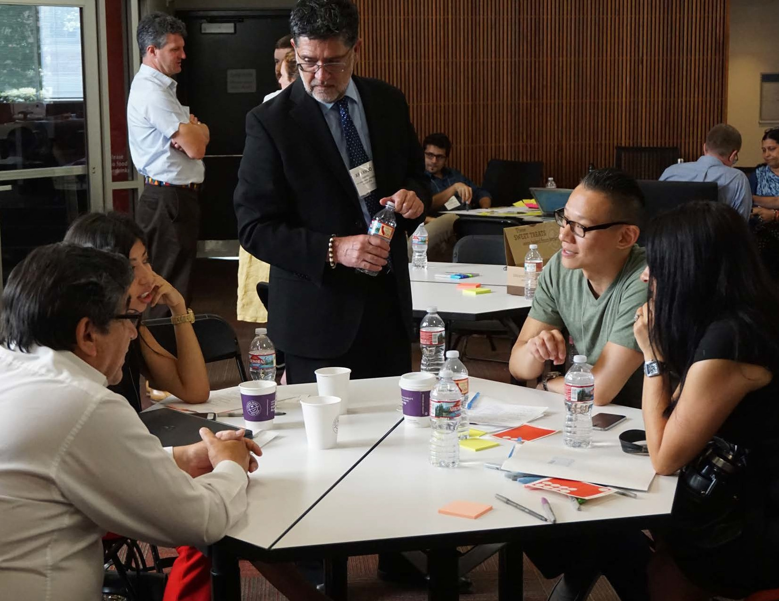
FORM A HOST TEAM
OVERVIEW — 6
1
To prepare for a Census Solutions Workshop, find partners who can complement your organization’s capabilities and reach different audi- ences. Together, work to build a guest list, find a space, and prepare the necessary materials.

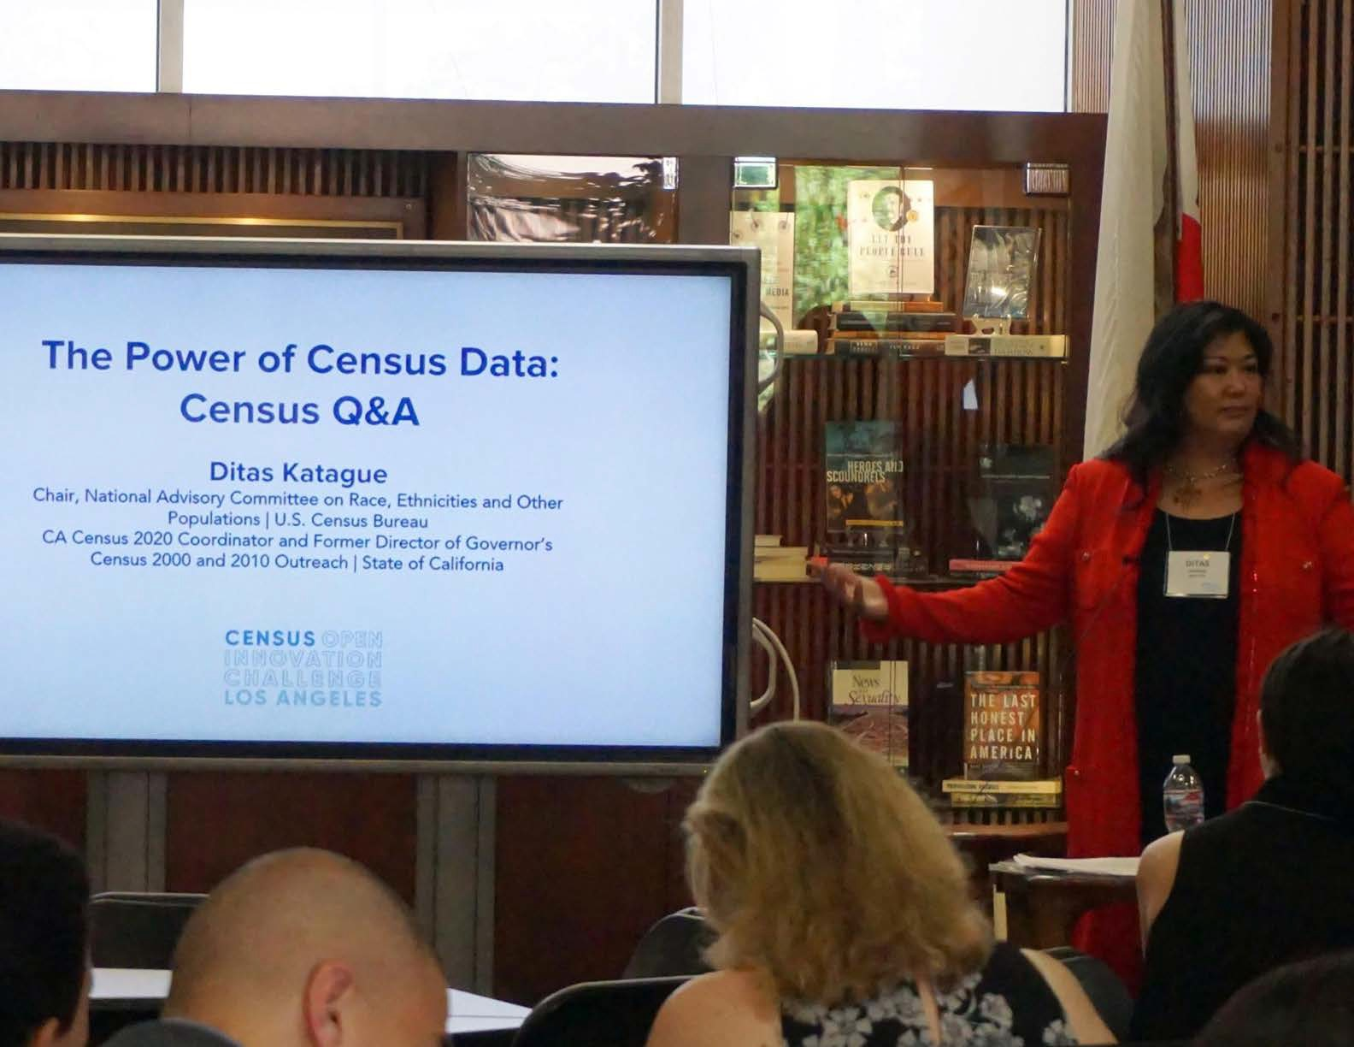
SETTHE STAGE
OVERVIEW — 7
2
A Census Solutions Workshop begins with a welcome presentation for all participants and an icebreaker exercise, setting the tone for a creative and collaborative session. The workshop facilitator should articulate the goals for the session and provide a brief Census 101 presentation—an overview of what the census is, why participation matters, and why 2020 outreach efforts need to be different than previous efforts.

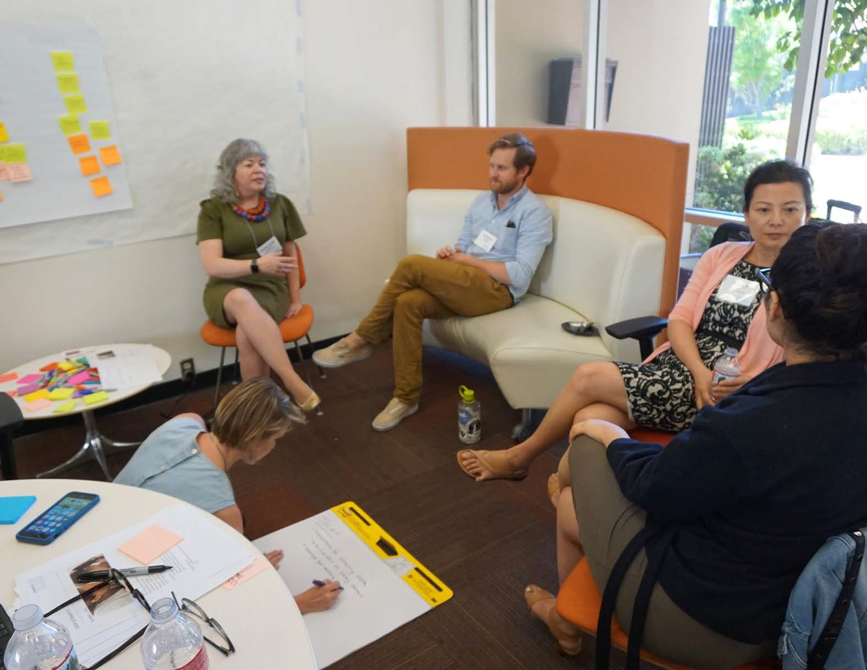
DEFINE SUCCESS
OVERVIEW — 8
3
The first exercises of the day are designed to get people comfortable with each other and cultivate a future-oriented mindset. Using specif- ic exercises, participants will go through a visioning exercise in which they imagine what a successful census participation effort would mean for their constituents. Participants can align on common goals by sharing their visions and voting on the most relevant solutions.

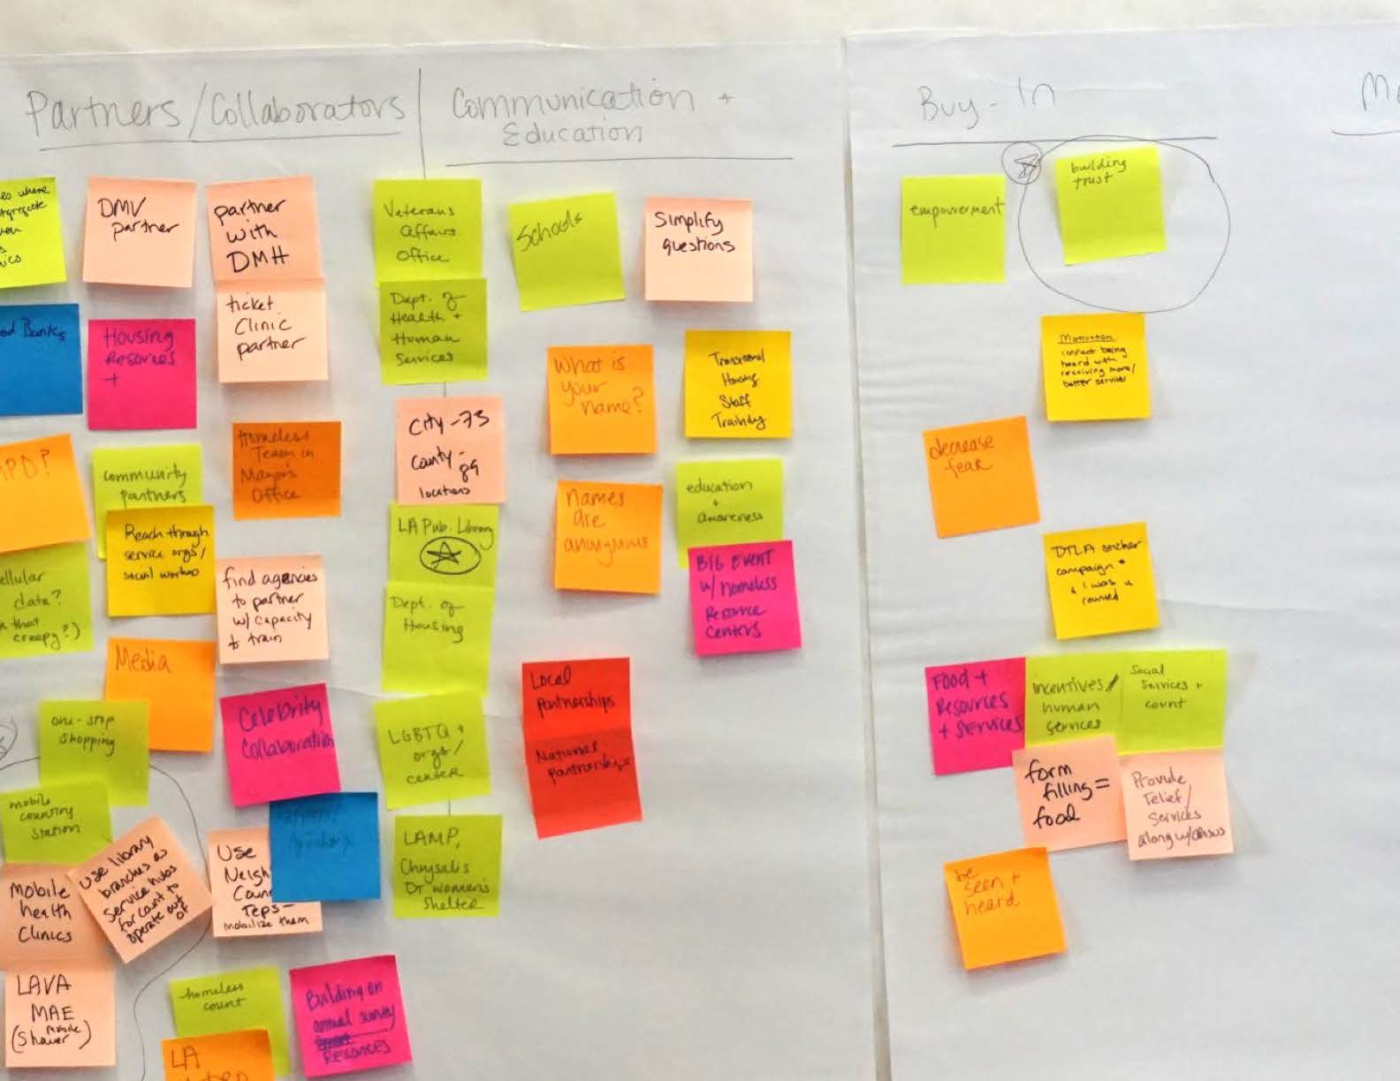
GENERATE IDEAS
OVERVIEW — 9
4
At each workshop, participants are asked to come up with ways to reach specific types of populations, who may be hard to count for a variety of reasons. Relevant user scenarios may be crowdsourced from attendees, provided by the facilitators, or generated by partici- pants. With the specific user in mind, participants generate as many ideas as possible—no idea is too crazy—and begin to cluster them around themes.

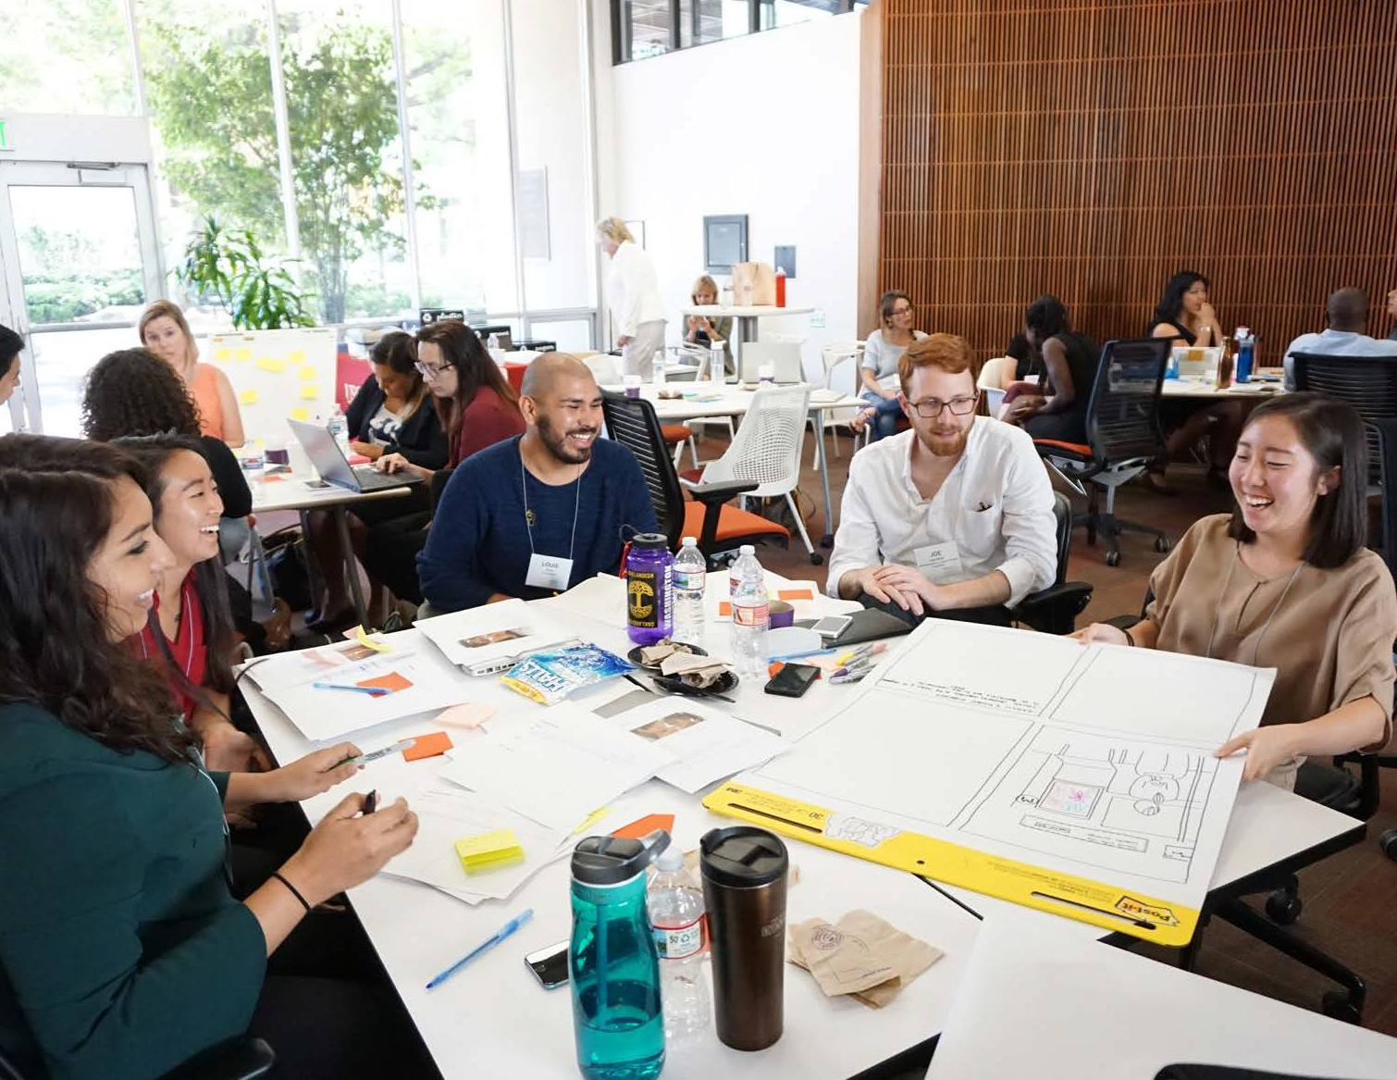
DEVELOP THE IDEAS
OVERVIEW — 10
5
In groups, participants decide on an idea to flesh out. Using a story- boarding exercise, the group is asked to think about how their idea could be made manifest. What would it take to plan and implement? What barriers might they face? What partners might they enlist? Each group develops a pitch to present to the other participants.

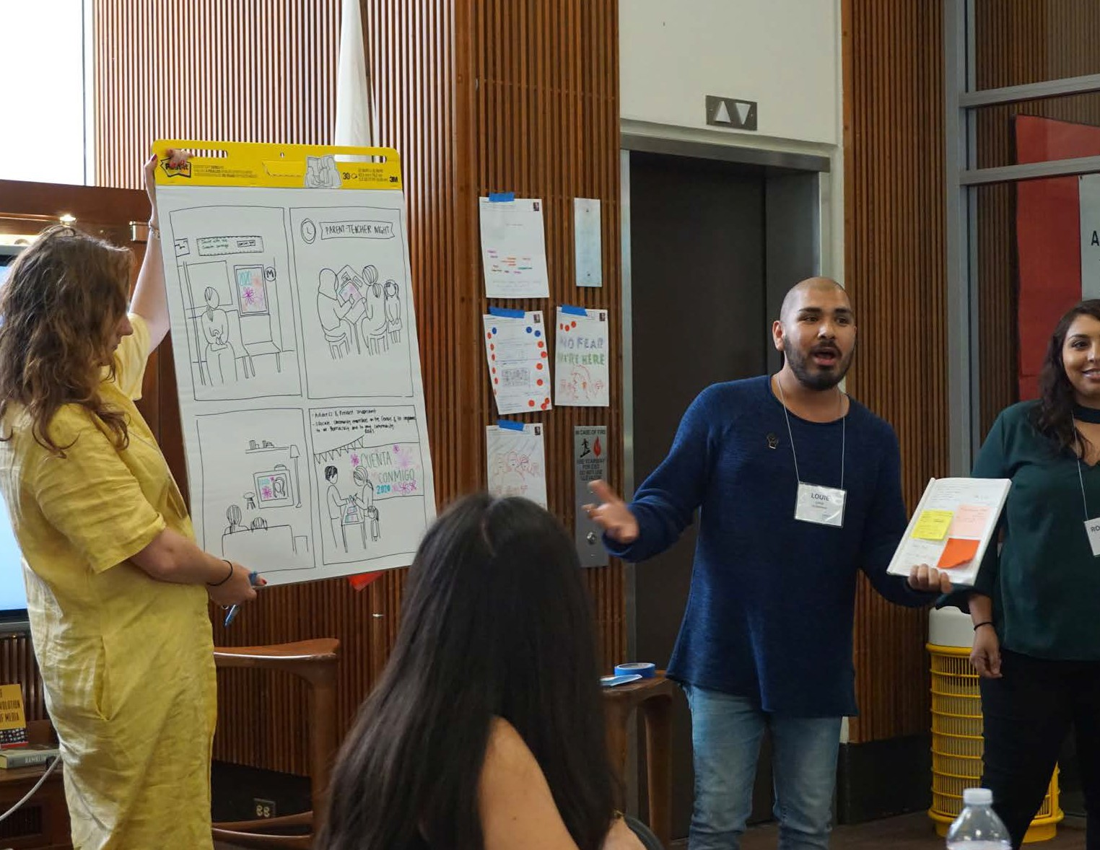
SHARE & DISCUSS
OVERVIEW — 11
6
Groups reconvene to pitch their ideas to each other. Each group pres- ents the solution it has developed, explaining the concept through drawings, diagrams, or by acting it out. Other participants are encour- aged to ask questions, probe further, riff on their idea, and consider ways in which they or the organizations they represent could help realize these ideas.

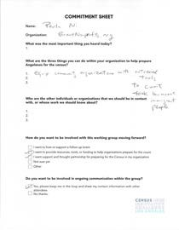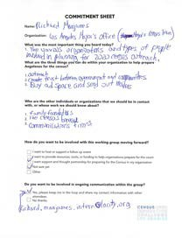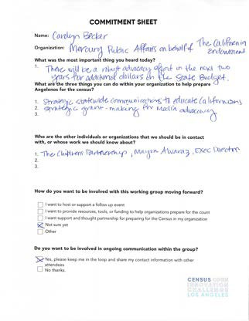

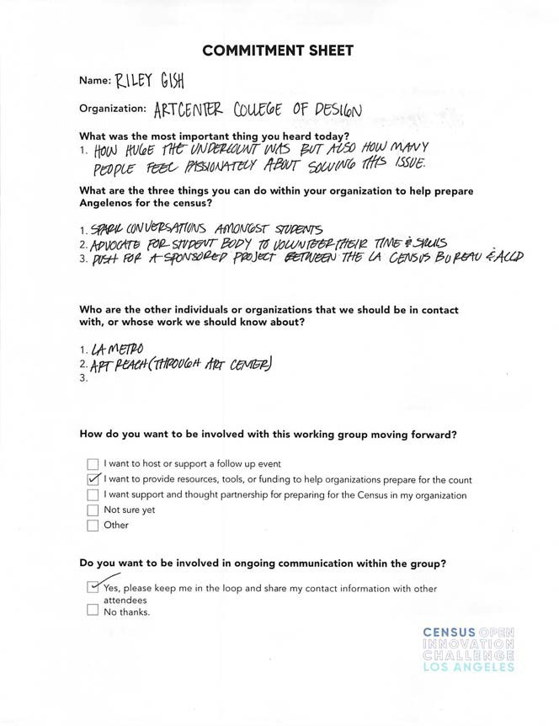
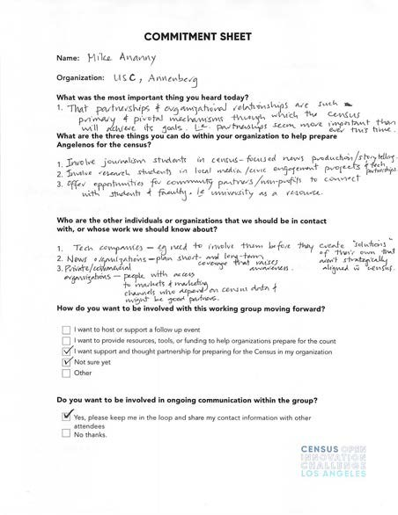
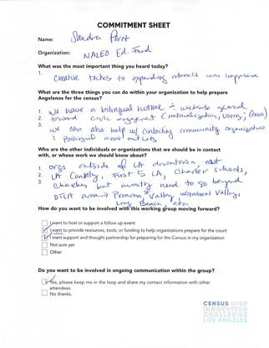
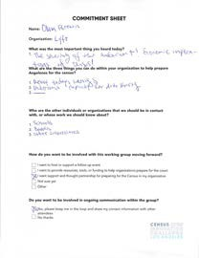
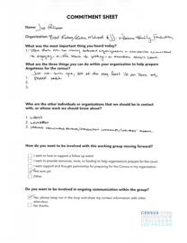
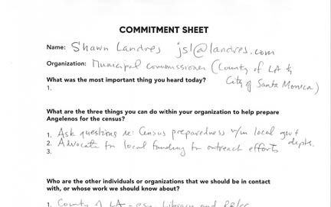
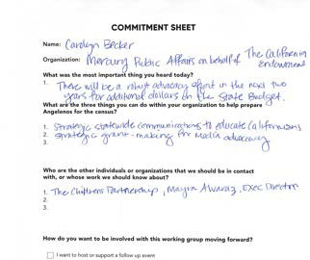
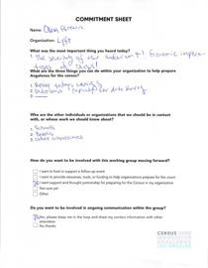
COMMIT TO CONTINUE
OVERVIEW — 12
7
At the end of the session, participants make public commitments of what their next steps will be in further developing and implementing these ideas. Using commitment worksheets, participants are asked to think about what they have learned today and what they or the organizations they work for can do to follow push towards the visions they articulated.

STEP 3
Invite & prep
Send out invitations, finalize your agenda and prepare any workshop materials you’ll need.
STEP 5
Keep going!
Thank your participants and ask them to make a concrete and realistic commitment to moving forward.
STEP 4
Host the workshop
Welcome your guests, lead them through warm-up, ide- ation, clustering, and prototyp- ing. Have them share out their work and get feedback and comments.

STEP 1
Build a team & get focused
Get a team of around 2-4 people together to plan and host the workshop. Begin by articulating the challenges you want to solve and what you hope to achieve by the end.
Decide on the length, format, and location of the work- shop, secure funding, spon- sorship if needed, and build your guest list.
STEP 2
Handle logistics

SOLUTIONS WORKSHOP

In response to feedback that partners wanted more out of their engagements with the Census Bureau, we designed the Census Solutions Workshop to benefit both partners and participants.

Goals of the workshop
- New types of partnerships
- New types of solutions
- Real commitments to doing the work
- Connect partners/participants to each other to grow partner network

How it helps Census participants
- Better targeting means better participa-
tion rates, which benefits communities.
- It creates new opportunities for large-
scale civic action.
- Creative solutions can help people un- derstand the vital importance of census data.

How it helps Census partners
- It results in groundbreaking ideas that would be more difficult to generate in a traditional event or meeting setting.
- It supports diversity of thought by bringing together organizations across sectors and industries, resulting in more creative, effective solutions.
- It’s an opportunity for business devel- opment and new connections around a shared mission.
- It results in new consortia of public-pri- vate partners, a proven model that can achieve significantly more than any one partner could on its own.
- It helps each partner better understand its audience, focusing on empathy and insights into the mindset, behaviors, and motivations of the end participant.

The Census Solutions Workshop is based on design thinking methodology. A common practice in the technology and business world, design thinking is a user-centered approach that has been increasingly adopted across the public sector to create impactful solutions to social challenges.

This approach is being used to take on things like designing the classroom of the future, creating more user-friendly hospi- tals, or ensuring that critical resources get to people living in poverty. We can use this approach to help solve census challenges, too.
The Census Solutions Workshop uses de- sign thinking to activate diverse people and organizations to solve challenges together in a hyper-interactive way.
This tends to be a lot more effective than
traditional brainstorming.
- It focuses more on action than on thought, forcing you to walk through scenarios and create real prototypes of ideas.
- It helps you visualize many ideas and thought streams so you can start to recognize themes.
EMPATHIZE
Get to know your users

ITERATE
Revise based on feedback
DESIGN THINKING
APPROACH
DEFINE
Articulate the problem clearly

PROTOTYPE
Test an idea with users

IDEATE
Generate solutions
- It allows a safe space for partici- pants to think outside the box .
- It helps participants turn off their “filter” and allow a plethora of ideas to be generated. (Even the more eccentric ideas will help inspire and unleash creativity, leading to big breakthroughs.)

Once a decade, this nation comes together to participate in the decennial census, creating national awareness of the census and statistics. This census provides the basis for reapportioning Congressional seats, redistricting, and distributing billions of dollars in federal funding to support your state, county, and community’s vital programs.

Everyone counts.
The census counts every person living in the U.S. once, only once, and in the right place.

It's in the Constitution.
The U.S. Constitution mandates that everyone in the country be counted every 10 years. The first census was in 1790.

It's about fair representation.
Every 10 years, the results of the census are used to reapportion the House of Representatives, determining how
many seats each
state gets.

Your data is confidential.
The law requires the Census Bureau to keep your infor- mation confidential and only use it for statistical research.

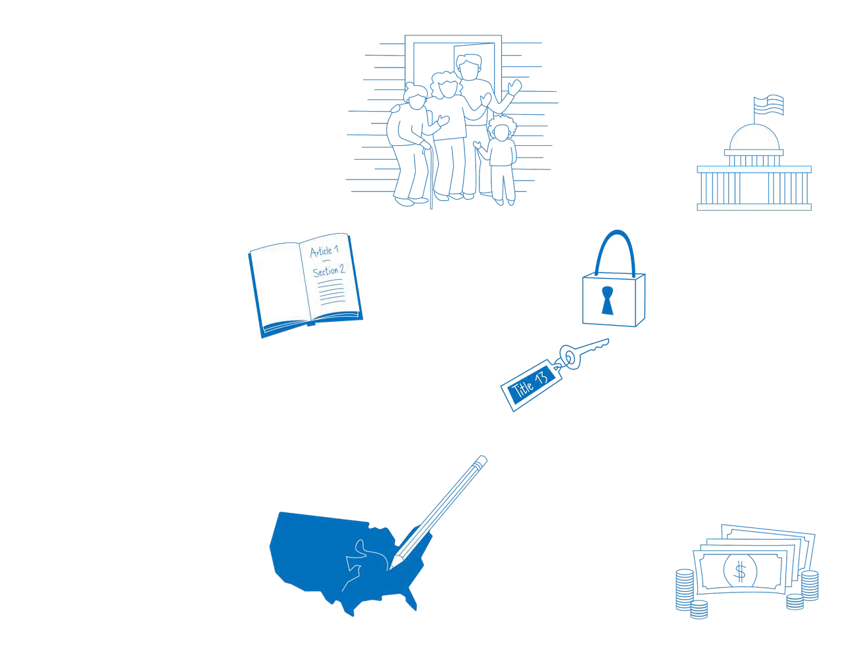
You can find a printable version of “Census 101” fast facts to share with your communi- ty in Part 5: Resources of the Census Solu- tions Workshop Toolkit.

It's about redistricting.
After each decade’s census, state officials redraw the boundaries of the congressional and state legislative districts in their states to account for population shifts.

It's about federal funding.
The distribution of more than
$675 billion in federal funds, grants and support to states, counties and communities are based on census data.
That money is spent on schools, hospitals, roads, public works and other vital programs.
We will never share your information with immigra- tion enforcement agencies like ICE, law enforcement agencies like the FBI or po- lice, or allow it to be used to determine your eligibility for government benefits.

OVERVIEW — 16

2— LOGISTICS

Everything you need to host a Census Solutions Workshop

Roles & responsibilities
- Everything you need to host a Census Solutions Workshop
- Planning timeline & checklist
- Build a team
- Define your goals
- Write 'Challenge Statements'
- Create your guest list
- Invite & survey
- Prepare your materials
- Select your scenario

While Census Solutions Workshops are not one-size-fits-all— they can range greatly in size, length, and approach*—these roles and responsibilities will apply in most every scenario.

Before
  - Who will be coordinating logistics such as securing the venue, providing food, ordering supplies, and printing out handouts?
  - Who will own and manage the guest list,
and send out the invitations?
  - Who will set the theme, goals, and agenda
for the day?
  - Who will determine the workshop activities
and facilitate them?
  - Who will prepare presentation materials?
  - Who will make sure all the hosts/facilita- tors understand the structure of the day?
  - Who will explain the activities to
the facilitators?
  - Who will find facilitators?
  - Who will reach out the Census for support or connections to local experts?

During
- Who will facilitate and host?
- Who will present?
- Who will check guests in?
- Who will manage day-of logistics, such as ensuring that food arrives on time?
- How many groups will there be?
- How many facilitators will you need?
- Who will explain each activity?
- Who will take notes?
- Who will take photographs?
- Who will keep time?
- Who will manage IT?
- Who will make sure the room is set up
ahead of time?

After
  - Who will create and send out a
follow-up email to the group?
  - Who will follow up with participants’ commitments?
  - Who will drive the strategy for what comes next?
  - Who will send feedback to the Census Bureau?

- For examples of workshop formats, see Part 4 of the Census Solutions Workshop Toolkit: Case Studies.

A CENSUS SOLUTIONS WORKSHOP

People
  - Facilitators
  - Participants representing a variety of
groups
  - Translators if necessary
  - At least one observer
  - Photographer / videographer (if needed)
  - Census Data Dissemination Specialist or other expert (optional)

Logistics
  - Venue, including enough tables and chairs for group break-outs and plenty of wall space
  - Refreshments (Drinks & snacks)
  - Music / portable speaker / sound sys- tem (optional)—to keep up the energy
  - Online invitation platform, e.g.
Splashthat or Eventbrite
  - Transportation if necessary
  - Parking if necessary/available

Supplies
- Flipchart paper + markers
- (e.g. Markers— one per person)
- Sticky notes (one pad per person)
- Dot stickers for dot voting exercise
- Tape
- Camera (and charger!)
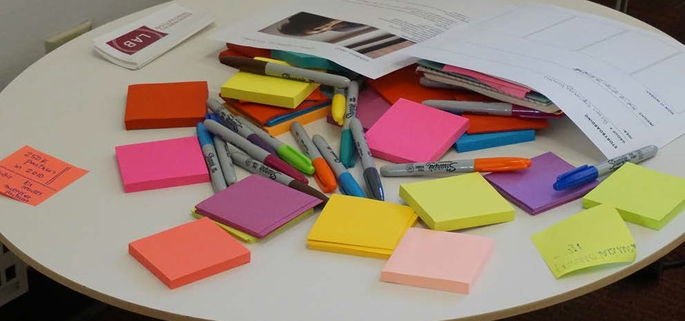
- Name tags

Workshop materials
  - Sign-in sheet
  - Media releases (if necessary)
  - Commitment sheets
  - Persona sheets
  - Presentation: "Census relevance to community"
  - Other relevant activity forms

WEEK 1
- Determine hosts, goals, and
purpose for workshop
- Decide event format & length
- Set a date
- Determine roles
- Begin scoping venues
- Set a budget, or in-kind needs (venue,
food, materials, videographer, etc.)
- If there are budget gaps, determine who will sponsor via funding or in-kind services
- Take a first pass at the guest list
WEEK 2
- Select venue
- Finalize guest list
- Send out invitations
- Continue to refine goals + agenda
- Draft user personas and Census 101 presentation
WEEK 3
- Decide which activities you would like to implement that will best achieve your goals
- Determine presenters and request any presentation mate- rials (slide deck, etc)
- Do a walk-through of the venue
and take photos
- Test A/V equipment
- Make a list of materials you
need and begin to order them
- Place food orders if necessary
- Secure videographer / photogra- pher, and provide creative brief if necessary
WEEK 4
- Finalize agenda
- Make any final edits to presentation(s)
- Send reminder emails to guests
- Pick up / collect supplies orders
- Plan room layout for optimal collaboration considering # of guests
- Consider how you want to form groups— day of or in advance?
WEEK 5
- Host the workshop!
- Debrief & capture lessons learned
- Send out thank you letters to participants
WEEK 6
- Collect and edit media (photo-
graphs, videos) as necessary
- Send feedback to the
Census Bureau

Hosting this kind of workshop is best done as a collaboration. As you’re looking for partners, think about which of the roles and responsibilities you feel comfortable taking on. Then, look for groups or people who have experience in the other areas.

Some questions you should consider

Making the most of partnerships
Partnering with others to host a workshop can be more efficient and increase the potential outcomes of the session. For example, at the Los Angeles Census Open Innovation Chal- lenge:
- USC Annenberg Innovation Lab brought in academic & technical knowledge
- California Endowment brought in financial support for the event
- Goldhirsh Foundation brought in strategic thinking, community clout, and connec- tions to new types of partners
- Will it be your own event or part of a larger event or conference?
- Will it be a shorter session of 1-2 hours, a half-day session, or a full-day workshop? (See sample agendas in Part 3: Activities)
- Is this something that your organization would like to take on individually, or would it help to have additional host partners or sponsors?
- Who are those who could add additional knowledge, financial or strategic support, technical assistance, physical space, brand recognition, or expand the guest list?
- Who might be able to offer a space?
- Who has experience running events?
- Who is connected to guests you want to reach?
- What diverse stakeholders can help during the planning and
execution of the event?
Start conversations early, and be sure to clearly lay out expecta- tions and responsibilities of each host partner.

The overarching goal of a Census Solutions Workshop is to generate new ways to engage people in census efforts;
however, the more specific you can make your objectives for the workshop, the better.

Specific goals will allow you to communicate clearly with your participants. In order to define your problem statement(s), consider these questions:
- What is the problem you’re trying to solve?
(For example: better reach hard-to count communities in your area, promote the value of Census data, increase participation in Census community events, etc.)
- Are you working towards reaching a specific demographic or community? Multiple communities?
- Are you finding new ways to scale existing programs and out- reach efforts?
- Is there a certain industry or sector you will convene, such as media or city government? Or is the problem better served by a more diverse or general audience?
- What groups and organizations could you help connect, who wouldn’t otherwise meet or convene?

By defining themes and insights, you’ve identified problem areas that pose challenges based on your goals for the session and tailored to your audience. Try reframing your challenges as “How Might We” questions to turn challenges into opportunities.

In terms of the topics you most want to focus on, you can keep it broad or get very specific and come up with prompts around spe- cific challenges, such as:

How might we...
Every problem is an opportunity. By framing your challenge as a ‘How Might We’ question, you’ll set yourself up for an innovative solution.
- Ask yourself if the question allows for a variety of solutions. If it doesn’t, broaden it.
- Your ‘How Might We’ question should generate a number of possible answers and will become a launchpad for the brainstorming activities.
- A good ‘How Might We’ question should give you both a narrow enough frame to let you know where to start your brainstorm, but also enough breadth to give you room to explore wild ideas.
- How might we educate caseworkers about the importance of counting people experiencing homelessness?
- How might we engage media companies to create new cam-
paigns that increase participation?
- How might we engage grassroots organizations and communi- ty advocates in creating awareness campaigns to minimize the undercount of young children?
- How might the library system or educational institutions serve as community hubs for Census education and awareness?
- How might we communicate the importance of the Census to underserved communities in low income areas?

Source: designkit.org/methods/3. To learn more about writing challenge statements visit: www.designkit.org

Once you’ve defined your goals, you can start to think about who should be invited. For this type of workshop, diversity matters. The most successful workshop bring together people of different ages, from different industries and sectors, with different priorities.

These events also depend on participants’ willingness to think outside the box. It can be helpful to include guests who you know will be energetic and enthusias- tic.
As you build your guest list, look beyond your own network, and be mindful of inclusion. Make phone calls to local officials and invite them or members of their staff.
Guests you might include could be: Small/local busi- nesses, community organizers or activists, govern- ment officials/employees, college/graduate students, artists, teachers, faith-based groups, social workers, non-profits, etc.
Before finalizing the list, ask yourself:
- Is there good representation of people who can tackle the problems from multiple angles? (e.g. businesses, community leaders, non-profits, professionals in different industries, etc)
- Are those you are aiming to serve represented in the room? (e.g. If you want to reach the homeless, do you have anyone who is, has been, or works with the homeless?)
- Does your guest list generally reflect the demographics of your community, city, county, or state? Does it include representatives of the hardest-to-count communities?

Your guest list is set. Use your invitations to highlight the benefits of attending the event and ask your invitees what they care about.

Invitations
Sample invitation
Hello,
We are excited to invite you to participate our first-ever Census Solutions Work- shop, to forge new cross-sector collaborations and identify new and innovative ways for reaching hard-to-count populations for the 2020 Census— and demon- strating the vital importance of Census data to the wellbeing of the country.
This daylong event will be held on [date] at [place]. Please join [conveners: sponsor organization(s), host organization(s), and the U.S. Census Bureau] in bringing together a community of local leaders, entrepreneurs, innovators,
funders, businesses and advocates to develop creative solutions that will move the needle on response rates among [target audience/population— i.e. Hard to Count] in [region, state, city, county].
For more information, agenda, and to RSVP, please visit the event page here. Please don't hesitate to reach out to [contact email] or at [phone].
Best,
The [Convener/Host/Sponsor Organization(s)] Team
Your invitations should explain the goal of the work- shop, give a plain language agenda, and tell them why this is important. Consider customizing each invita- tion to highlight why that invitee would want to be in attendance.
- Join other leaders in the community…
- Ensure your community is represented…
- Connect with representatives of X, Y, Z…

Pre-event survey
Asking your invitees what they care about has a dual purpose. One, it helps you plan the event and know what user scenarios to prepare. Two, it gives invitees a sense of buy-in. For example, you could ask them:
- What are your two main concerns about the 2020 census?
- What are the groups or geographies you are most interested in brainstorming ideas about reaching for the 2020 Census? (Here you can offer sugges- tions for them to rank or leave it open-ended.)

Find a sample pre-event survey in Part 5: Resources of the Census Solutions Workshop Toolkit. We recom- mend using a digital survey tool.

With the major logistics taken care of, turn your attention to preparing for the activities of the workshop. Take our materials and make them your own.

Presentation
We recommend having a simple slide pre- sentation to guide you through the day. We have created a presentation deck for your use, which you are welcome to modify. This lays out the structure of the presentation and what to include.
In customizing our example deck or creat- ing your own, think about and try to answer the following questions::
- What will resonate with your audience?
- Can you make your presentation specif- ic to your city, county, state, etc?
- Why does this matter? Why are the stakes so high?
- Why were these particular guests invit- ed to participate in creating solutions?
Naturally, you should ensure that your space has a projector or large screen be- fore working on this piece. If it does not, we recommend creating a handout that you can walk through with the participants.

Census 101
We recommend starting the day with a very brief Census 101 talk to make sure every- one is on the same page.
Using our Census 101 infographic as a starting point, ask yourself:
- What are some examples of census data being used to the advantage of the communities that the audience rep- resents?
- Which elements of the census’ impact are most relevant to your audience (e.g. federal funding vs. representation vs. redistricting, etc)?
We encourage you to seek expertise in communicating the importance and rele- vance of census data. There are regional Data Dissemination Specialists and Part- nership Specialists who may be able to attend your event.
Contact a data expert at 1-800-ASK-DATA
or census.askdata@census.gov.

Print materials
We recommend preparing a packet of materials for each attendee. In addition to worksheets that they will use during the activities, we encourage you to give them a few pieces that they can take with them.
These might include:
- an agenda with hosts names and con-
tact information and a list of attendees
- a Census 101 fact sheet
- information on how to partner with the
Census Bureau
- an overview of the biggest barriers to participation in Census surveys
We have included a number of these items in the Resources section of this toolkit for easy printing, including:
- Cover Story worksheet
- Fleshing out your idea worksheet
- Commitment sheet
- Feedback form
LOGISTICS — 11

There isn’t a one-size-fits all solution to increasing participation in the census. The solutions generated in the workshop should respond to specific user scenarios. You should prepare these ahead of time based on the attendees’ feedback.

User scenarios & personas
User scenarios help participants root their discussions and solutions in deep empathy for the people you want to reach. You’ll want to decide on user scenarios that are appropriate to your event and participants in advance.
We recommend introducing these user scenarios in the form of personas. You will invent personas that repre- sent the characteristics of the demographic you want to serve. Making personas as fleshed out as possible is helpful in getting participants to understand the mind- set of this person. At a minimum, each persona should
clearly demonstrate one of the barriers to census partic- ipation.
Once you’ve received responses from attendees, you can decide how many different user scenarios to focus on, how detailed the personas should be, and whether to pre-assign groups or let participants choose which persona to focus on at the workshop.

Barriers to participation
There are four primary barriers that research has iden- tified as particularly common reasons for not complet- ing the Census:
  - Trouble completing the forms, due to barriers in language or literacy
  - Not understanding what the census does and why it’s important for them
  - Assuming the Census will be time-consuming and cumbersome
  - Lack of trust in government
  - Concerns about data privacy or having their infor- mation used by other federal agencies
You can use these examples of sample user scenarios created for a previous partner event, or generate your own user scenarios particular to your community or specific challenges you want to focus solutions on.

LOGISTICS — 12

3— ACTIVITIES

What to do at a Census Solutions Workshop

Sample agendas
- Set the stage
- Intro & icebreaker
- Census 101 & goals
- It’s not 2010 anymore
- Cover Story
- Choose a user scenario
- Brainstorm
- Dot voting
- Develop the ideas
- Pitch & discuss
- Commit & wrap
- Next steps

Full-day workshop
Half-day workshop
One-hour workshop

8:30 AM
9:30 AM
10:00 AM
10:30 AM

10:45 AM
11:00 AM
11:10 AM
11:20 AM
11:30 AM
11:45 AM
12:00 PM
12:45 PM
1:00 PM
1:30 PM
2:20 PM
2:30 PM

3:00 PM

3:15 PM

3:30 PM
Arrive & set up room
Guests arrive
Introductions & icebreakers Presentation:
Goals & Census 101
Break
It’s Not 2010 activity Cover Story
Dot Voting
Present user scenarios Solo ideation
Lunch
Clustering in groups
Group brainstorm & pick idea
Groups develop idea
Break
Groups share ideas with each other
Commitment sheets & feedback form
Recap accomplishments of the day
Coffee, snacks, networking (optional)
8:00 AM
8:30 AM
9:00 AM
9:20 AM

9:45 AM

10:00 AM
10:10 AM
10:30 AM
10:45 AM

11:30 AM

11:45 AM

12:00 PM

12:15 PM
Arrive & set up room
Guests arrive
Introductions & icebreakers
Present Goals, Census 101, It’s Not 2010
Present user scenarios & form groups
Solo ideation Clustering in groups Break
Groups pick idea & develop it with storyboards
Groups present ideas to each other
Commitment sheets & feed- back form
Recap accomplishments of the day
Lunch (optional)
8:30 AM

9:00 AM

9:20 AM

9:40 AM
9:50 AM
Set up stations with different user scenarios around the room
Introductions, goals, user scenario
Solo ideation
(5 minutes at each station)
Share out ideas
Make commitments & complete feedback form

ACTIVITIES — 3

Ideally, you can hold the workshop in an attractive, comfortable space with lots of natural light, but that’s often not possible. Don’t worry. A few small touches can transform a space and signal to guests that the event will be exciting and creative.

Arrange the space
    - Make sure you arrive with plenty of time to set up the space, at least an hour before participants are set to arrive.
    - Make sure there are enough chairs and that there is easy access to the walls. You may need to rearrange some of the furniture.
    - Identify where you will be presenting from (if there is a projector) and make sure chairs are oriented towards that spot. Test the projector and get your presentation loaded.
    - Set up a station for registration near the door with name tags, markers, and a sign-in sheet.
    - Set up a flipboard with markers at the front of the room for the “21st Century Mindset” activity.

Arrange the space
A few small touches can make the event feel more official and get people excited.
- Set the tables so that each person has a set of materials they can refer to, use, and take with them. At each place, put:
  - Agenda with list of attendees and your contact information
  - Census 101 handout
  - Cover Story worksheet
  - Storyboarding worksheet
  - Commitment sheet
  - Feedback form
  - Pad of colorful sticky notes
  - Set of colorful dot stickers
- Make sure there are plenty of markers
and pens/pencils on each table.
- Set out refreshments on a table so attendees can help themselves. Play some energetic music over the sound system (at a low level).

Greet your guests
- As guests start to arrive, have someone or several people greet them. Make sure they add their contact information to the sign-in sheet so you have a record of who was there and can follow up with them after the event.
- Let guests know where the nearest
restroom is.
- As you wait for everyone to arrive, make introductions between attendees and encourage them to mingle.
- If possible, have each table represent different organizations, departments, functions, etc. If you are assigning groups ahead of time, try not to group people who spend a lot of time together.
- The diversity of the group will help strengthen your ideas and lead to inter- esting new collaborations.

ACTIVITIES — 4

It’s important to set the tone of the day from the very beginning. The workshops are meant to be high-energy, creative, and interactive. People need to feel comfortable—which means they need to know what is going to happen and who they are with.

Introductions
Start by welcoming everyone to the Census Solutions Workshop. Introduce yourself and the other hosts and organizers first.
Be sure to give proper acknowledgements to all those involved in the planning and resourcing of the event.
Go through the agenda so everyone knows what to expect. Tell everyone where the nearest restroom is.
Finally, tell everyone—briefly—why you are hosting this workshop. You’ll go into more detail in your presentation.
  - “Our goal is to learn more about the communities you serve.”
  - “Our goal is to bring together people from the private and public sector in our community who might not otherwise meet.”
  - “Our goal is to find opportunities to col- laborate in census outreach.”

Icebreaker activity
We have found that an icebreaker activity is essential to a productive workshop. Begin by having everybody introduce themselves. If the group is too large, they can do intro- ductions at their table, but it’s ideal if every- body can get a sense of who is in the room.
- “Tell us your name, what group you rep- resent, and what your first concert was.”
If time allows, try this icebreaker activity de- signed to get everyone in a focused, reflec- tive, and engaged frame of mind.
- “We’re all here because we care about people being represented. We’re going to start with an activity to dig a little and make sure we’re clear about our pur- pose.”
- “Let’s begin with an individual activity.”
- “Take 5 sticky-notes and write down the fears you have about solving these prob- lems—one idea per sticky.”

- “Next, take 5 sticky-notes, and write down why you showed up today and who you’re doing this for”
- “Now, take the 5 sticky notes with your fears and tear them up—go on, tear them—we won’t need those here today.”
- “Today is all about thinking big. We won’t come up with any perfect ideas today, but the more ambitious we can be, the better.”
- “It’s not about coming up with the an- swer—it’s about inspiring each other and allowing ourselves to find connections we wouldn’t have otherwise.”
- “Now, take one of your five remaining sticky notes and go around in a circle at your table, introduce yourself, and share why you decided to come and what you hope to accomplish today.”

ACTIVITIES — 5

Once everybody has been introduced, give a brief presentation to get all participants on the same page. This is your opportunity to express the importance of census participation to this particular audience and set out the goals of the day.

Census 101
Each Census Solutions Workshop is differ- ent, but it’s a good idea to refresh partici- pants’ understanding of the value of census data and the importance of participation in the 2020 Census or other Census surveys and programs.
The Census 101 presentation should cover three topics:
  - What the Census Bureau is, what it does, and why it matters
  - Most common barriers to participation in census surveys and programs
  - How this matters to the audience in the room
At a minimum, everyone in the room should know:
  - The Census Bureau's mission is to serve as the leading source of quality data about the nation's people and economy.

- We honor privacy, protect confidentiality, share our expertise globally, and conduct our work openly.
- In 2020, the U.S. Census Bureau will con- duct the Decennial Census, which counts every resident in the United States.
- The data collected by the decennial cen- sus determine the number of seats each state has in the U.S. House of Representa- tives and is also used to distribute billions in federal funds to local communities.
- The census helps our communities de- termine where to build everything from schools to supermarkets, homes to hospi- tals.
- It helps the government decide how to dis- tribute funds and assistance to states and localities. It is also used to draw the lines of legislative districts and reapportion the seats each state holds in Congress.

Goals
Before launching into the next activity, be sure to clarify your goals in hosting this workshop as well as what you expect to accomplish by the end of the day.
  - “We brought together this group of peo- ple to strengthen ties in the community.”
  - “We are hosting this workshop as an opportunity for cross-sector thinking to ensure the representation of our com- munity in the 2020 Census.”
  - “By the end of the day, we expect you will have come to understand the per- spective of those not participating in the census and have some new ideas about how to reach them.”
  - “At the end of the day, we expect you to think about the kind of commitment you or your organization could make towards these new ideas.”
ACTIVITIES — 6

This group activity is intended to shift participants mindset towards the future. By reminding them of how much of our world has changed, you are priming them to come up with future- focused ideas for the rest of the day.

Introducing the activity
In this activity, you will ask the group to think about what has changed since 2010 (or earlier). The point of this exercise is to emphasize that old outreach strategies are not enough, and that there are new oppor- tunities to connect with audiences.
You can introduce this activity with some slides, or go right into writing on a flipboard.
    - “Think about things that have completely changed. We used to use movie rental stores like Blockbusters, now we’re all streaming. We used to stay in hotels; now we can stay in people’s homes via Airbnb.”
    - Set up one column with the heading “2010” and another with the heading “2020” side by side. Begin with some ex- amples yourself, then ask the attendees to chime in.
    - “What’s different about air travel?”

- “How has getting your prescription changed?”
- “What’s different about going to the bank?”
To find more examples, consider comparing the annual mindset list of incoming fresh- man college Class of 2020 and Class of 2010 to see what to them has never existed or has always existed.
Finally, have participants add anything else in the environment for their constituencies or geographies that will be true in 2020 that wasn’t in 2010.
- “How will your audience’s economic situation be different?”
- “What has changed about your constituency’s political views?”
- “Have the people you serve been affected by any societal or environmental changes?”

ACTIVITIES — 7
2020
Netflix Uber + Lyft Expedia Airbnb Amazon
2010
Blockbuster Taxi cabs Travel agency Hotels Brick+Mortar

This five-minute exercise can be used to uncover shared goals and gives workshop participants permission to dream big. This can lead to realizing true possibilities that were once unimaginable.

Why
One of the most effective techniques to recognizing common dreams people have is to ignore all limits and imagine what “could be.” During this creative activity, par- ticipants imagine a future accomplishment so spectacular that it gets published on the front page of a newspaper or magazine.
By freeing yourself from all constraints, you can release your imagination and think big in order to realize what direction your group should move toward. While some of the stories may seem extravagant, the col- lective thinking process may uncover real possibilities for the future.

How to do it
1

How long it takes
10-20 minutes

What you need
- Cover Story worksheets
- Magazines for inspiration
- Markers

Source
The Grove (innovationgames.com/wp-
content/uploads/2011/06/
HTMLCoverStory-IG.txt)
Using the Cover Story worksheet in Part 5: Resources of the Census Solutions Workshop Toolkit, instruct each participant to imagine the headline that they’d like to see as a result of their efforts. This can be done individually or in groups. Have a few magazines on the tables for inspiration.
  - “Imagine it’s 2021 and there’s a cover story featuring the success of the 2020 Census thanks to your contribution. What does it say?”
2
Each Cover Story should include a headline and subhead, and could also include sidebars, quotes, images, etc.
3
Have each group present their big-picture ideas. As a team, work to recognize any commonalities among the stories and reflect on how these similarities can actually be applied.

There are common barriers that Census and external research have identified as particularly common reasons for not completing the Census—use these or other user scenarios to help participants be concrete in their ideation.


Why
There isn’t a one-size-fits all solution to increasing participation in Census programs and surveys. It is key that those creating new solutions under- stand who those solutions are being built for. User scenarios and personas help participants root their discus- sions and solutions in deep empathy for the people you want participating
in the census. “I don’t trust the government with my information.”
Your audience is concerned about data privacy or hav- ing their information used by other federal agencies.

“I have trouble completing census forms.”
Your audience may not be native English speakers and find Census forms con- fusing.





“I don’t think the census has any impact on my life.”
Your audience isn’t sure what Census does, how its data affects them, and why their participa- tion matters.

“I don’t have time to fill out the census forms.”
Your audience is very busy and assumes the Census will be time-consuming and cumbersome.



Brainstorming is the basis of the day’s activities. There are a variety of formats this can take—from silent ideation to group brainstorm, but the key is to ensure a generative mindset, withholding for the moment any judgment or criticism.

Why
It’s important to remember is that ideation is about generating as many ideas as possible—quantity over quality. It’s not about coming up with the perfect idea, it’s about making new connections, being inspired by each other, and allowing the group to go beyond the obvious solutions.

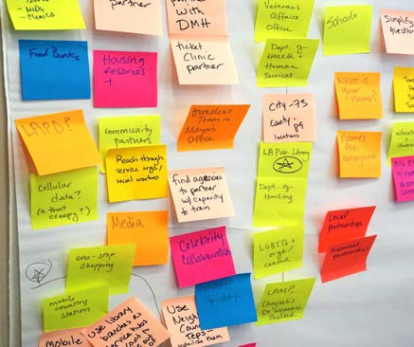

How to do it
- SILENT BRAINSTORM
Have all participants generate as many ideas as possible, in silence, for new ways to reach the persona they’ve selected. There are no bad ideas! Have each participant write down (or draw) one idea per sticky note. Have lots of sticky-notes and markers at every table!
  - “We’ll start by brainstorming about the user you chose in silence—it’s important that you not compare notes at this point.”
  - “Where does this person spend time? Who do they trust? What would make them partic- ipate? What do they care about? How might you reach them?”
  - “There are no bad ideas. Everything you come up with is valuable, as it can spark ideas for other people. Don’t worry about feasibility.”
- SHARE
Share ideas by question (i.e., what did people write down for “Who do they trust?”)

- CLUSTERING
During share out, begin to cluster ideas around themes—move the post-its around so that similar ideas are grouped together.
- BUILD
Within each cluster, do one more group ideation. Combine elements of ideas or build on each others’ ideas. It is important that this be a generative process. Use
the phrase, “Yes, and…” to acknowledge others’ ideas and maintain a framework of collaboration and accumulation of ideas.
- CHOOSE
Decide which idea has the most potential and / or excitement among the group. This will be the idea you will start fleshing out in the subsequent exercises. If your group is having trouble reaching a consensus, you can use the dot-voting exercise described earlier.

Use this method to quickly identify common interests and align on next steps. Dot voting can be used after either solo or group ideation.

Why
To reach a consensus on priorities of goals, ideas, or themes for the day with a group of people. This is especially helpful with larger groups of stakeholders and groups with high risk of disagreement.

How to do it
1
Have participants post their ideas on a wall. This might be in the form of their Cover Story worksheet, sticky notes, or group storyboards.
2
Give participants three to five colored stickers and instruct them to place their stickers on the ideas they feel are most important to meeting the goals and user needs. Participants can use all / multiple of their stickers on one idea they really like, or spread them out to multiple ideas, but should not vote on their own ideas.
3
Identify the ideas with the largest number of stickers (votes). Discuss them briefly and use them to inform the next exercise (setting a focus or aligning on a goal).

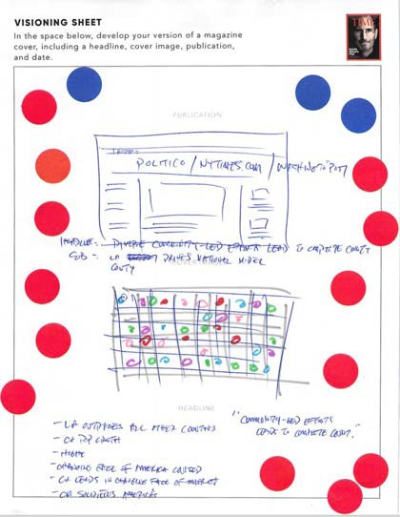
Real example of a Cover Story generated at the L.A. workshop after dot voting exercise.

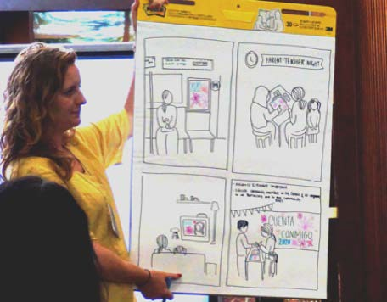
In order to flesh out the ideas generated, the next step is to create a storyboard—a drawn version of the idea on your sticky-note. This should capture the interactions and relationships that might exist between a user and a solution in the context of their full experience.

How to introduce it
In order for the solution ideas generated to be able to be taken further, groups need to elabo- rate and begin to imagine more concretely how they could be put into action.
Introduce this part of the workshop clearly:
  - “In your groups, your task is now to align on one idea for a solution—it could be one of yours, or a combination of several ideas— and get more specific.”
  - “Using the worksheet, we want you to think through what would have to be in place for your idea to become a reality. Who would have to approve this? What resources would it take?”
  - “You are preparing to pitch your idea to the rest of the group. The most important
thing is that the idea be very clear. Consider how you want to explain it to the rest of the participants—you could draw a storyboard, make a prototype, or act it out.”

What they'll do
- DECIDE ON A DIRECTION
Align on which idea you want to present and talk through these questions:
  - Who is our idea designed for?
  - What is a tool, campaign, program, or other activity that we can create?
  - How are people going to find out about it?
  - How does it make people feel?
  - Who can we partner with?
  - What are the existing resources around this table to pull this off?
  - What are references for this kind of idea?
  - What is the call to action?
- GET SOME REFERENCES
Gather any documents that describe the different use cases or scenarios in which users will interact with your service, campaign, or idea for getting out the count.

- SKETCH
Sketch scenes that visually depict a user interacting with the service, including as much context as possible. For example: Are they on the move? What else is in their environment?
- ANNOTATE
Annotate each scene with a description of what the user is attempting to do. Describe what general feeling or experience the team wants the user to have.
- REFINE
Create a polished version of the storyboard that you are comfortable sharing with the larger group. The point here is not the quality of the sketch, but a well-conveyed concept that can work in the real world.

Reconvene all the groups and ask each group to present its idea to the rest of the room. The goal is for them to succinctly articulate their idea, leaving enough time for other participants to ask clarifying questions and give suggestions.

Pitch structure
Make sure each group has a structure
to follow:
  - Describe user
  - Identify barrier to census comple- tion
  - Walk through storyboard of inter- vention
  - Identify what would need to happen for this to be implemented: What materials/capabilities are needed?
  - Ask for feedback

Discussion
Once the group has presented, moderate a discussion around the idea. You can start by opening it up to questions from the oth- er participants.
If nobody has a response, you can solicit reactions from the room with questions like these:
  - Has anyone here ever heard of a solution like this being successful?
  - In your wildest dreams, what would the impact of this solution be?
  - What are the biggest barriers to imple- menting something like this?
  - Is there anybody in the room who might be able to help make this a reality through their connections, resources, expertise?

The final piece of a Census Solutions Workshop is to have participants make a commitment to move the group idea forward. This can take many forms—it could be a commitment of resources, a commitment to stay in touch, to host another workshop, etc.

Commitments
OPTION 1: PRIVATE
Distribute Commitment sheets and ask all partici- pants to fill them out and turn them in to you. While it is tempting to send these as follow-up surveys, we have found that it is important for the commitments to be made as part of the workshop. Be sure to leave 10 minutes for this activity.
OPTION 2: PUBLIC
If time permits, have participants share their commit- ments with the group, either in addition to or in lieu of filling out the worksheet.. Research suggests that when people make public commitments, they are much more likely to follow through.
If you do commitments verbally, make sure someone from the host team is documenting the commit- ments and ascertaining whether or not participants are willing to be contacted going forward.

Real example of a commitment sheet generated at a workshop in Los Angeles.

Wrap the session

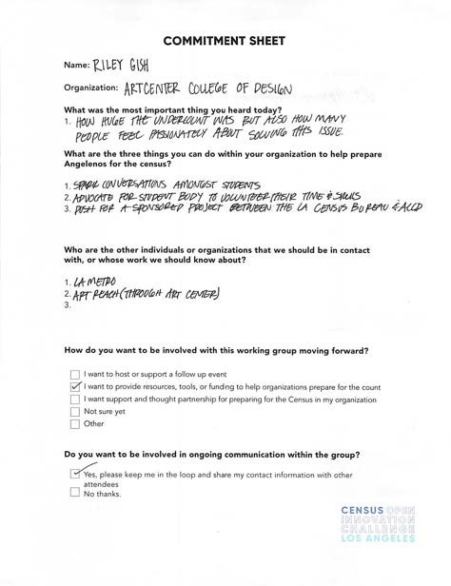
At the end of the session—whether it has been an hour or a full day—make sure to thank your participants, reiterate the value they have brought to the session, summarize the out- comes of the session, and let them know what your next steps will be.
  - “Thank you so much for being here today and participating. Participation in the 2020 Census is an enormously important cause, and we really appreciate your creativity and collaboration.”
  - “We started the workshop with this goal: ….”
  - “Today, we achieved: …”
  - “As a next step, we will: …”

Do not underestimate how important it is to follow up with participants after the workshop. Sending a timely thank you and re-articulating the outcomes of the workshop signals your respect for the participants and maintains momentum.

Debrief with the team
Set a time to debrief with your team and discuss the outcomes of the workshop. Consider the following questions:
    - What went particularly well?
    - What surprised you?
    - What did not go well? Why?
    - What would you do differently if you hosted another workshop?
    - Would you be interested in hosting an- other workshop?
    - Which activities were most effective?
    - Were any of the activities confusing or ineffective? Do you need more guidance?

Thank you notes
Be sure to write a thank you/recap email to the participants. Share your enthusiasm to continue to work together towards census solutions, and any additional resources you want them to have that you didn’t get a chance to share during the event.

Feedback
Ask them to share their feedback—and please share that feedback with us!
We are always looking to improve this toolkit, and your learnings are invaluable. Distribute the Feedback Form from Part 5: Resources of the Census Solutions Work- shop Toolkit, or distribute a short survey like this one.
Document the commitments made at the workshop and send it to census.partners@census.gov.

4— CASE STUDIES

What we’ve learned from past Census Solutions Workshops

What we’ve learned so far
- Full-day workshop:
Census Open Innovation Challenge
- One-hour workshop:
L.A. Mayor’s Office
- Session at a conference: Urban Institute, Baltimore

WHAT WE'VE LEARNED

Census staff and partners have tested this workshop model in multiple formats — ranging from a session at a conference to an all day, standalone event.

Benefits of a workshop
Early pilots of this workshop format have been highly effective for solving census challenges, such as:
    - Reaching key hard-to-count populations
    - Showing the value of census data in a tangible and impactful way
    - Engaging hard-to-count businesses to participate in the Economic Census
    - Activating the private sector to co-de- sign new and better uses of the census data
    - Creating new connections and networks all invested in a complete and accurate count
Participants have also found that gathering a diverse group of stakeholders and organi- zations in a room together leads to ground- breaking partnerships that might not have happened without this approach.

Lessons learned
- Don’t skip a step. Each piece of the workshop is important. It’s tempting to cut the icebreaker exercise when you’re short on time, but we’ve found that it’s essential groundwork for the activities to come.
- Define the mindset. These workshops depend on participants having permis- sion to suggest wild, impractical ideas and adopt a forward-thinking perspec- tive. Set that expectation early.
- Act it out. These activities are new for a lot of people, so before launching into an exercise, really make sure everyone is clear. It can help to quickly demon- strate how the activity will work.
- Work on what matters. Participants should be able to use this event to develop their thinking around the people they serve.

- Facilitation takes practice. Partnering with people or groups who have expe- rience putting on events and organiz- ing activities are great to have on your team. It’s also a good idea to run- through the event in advance—rehears- ing will make you more confident and help you identify what’s missing.
- Make time for mingling. The chance to meet new people is a big motivator to attend these events, so make sure there is a way for people to talk to each other. You could have a lunch break or a post- event snack / happy hour / dinner.

GUIDING QUESTION

How might we create new solutions for reaching hard- to-count communities in Los Angeles and beyond for the 2020 Census?

Who hosted
  - University of Southern California
  - Annenberg Innovation Lab
  - The Goldhirsh Foundation
  - The California Endowment

Who participated
Diverse partners in Los Angeles across the public and private sector—civil society, government, the private sector, creative industries and more.

Format
All day workshop with lunch provided—see the sample agenda for the full-day work- shop to follow this format.

Methodologies
After defining what success in 2020 would like, groups decided which type of person they wanted to create solutions for, based on different personas that were presented. Then they used various activities (ideation, dot-voting, storyboarding) to come up with creative new ideas and share them out.

Outcomes
- Dozens of publicly-shared
commitments
- New collaborations across sectors and industries
- Participants found the methodology very useful and wanted to run their own workshops!

Following the Los Angeles Open Innovation Chal- lenge, a team from the Mayor of Los Angeles’s office were inspired to create their own workshop internally across the organization.

GUIDING QUESTIONS

What is our vision of success?
What are the barriers and motivations of hard-to-count communities in our city?

Who hosted
Key representatives from within City Hall

Who participated
Members of Mayoral staff

Format
One-hour working session

Methodologies
The overall goal was to get the staff think- ing and excited about the 2020 Census.
The leaders of the session created their own infographic to show other team mem- bers why the Census matters. From there, they did the Cover Story exercise, and dug into potential motivations for hard-to-count populations.

Outcomes
In only an hour, the workshop achieved the goals of getting staff to think big-picture, collaborate with others, and get excited for the upcoming Census.

GUIDING QUESTION
URBAN INSTITUTE
CONFERENCE SESSION

How might we mobilize our organizations around the 2020 Census?

Who hosted
  - Leaders in Innovation from the
U.S. Census Bureau
  - Urban Institute
  - National Neighborhood Indicator Partnership

Who participated
Representatives from cities, universities, and advocacy groups

Format
One-hour session as part of a national conference

Methodologies
In this small session, participants used ideation to create new concepts and com- mitments to the 2020 Census.

Outcomes
Numerous new commitments were shared, including city-hosted workshops and ex- ecuting ideas like a neighbor-to-neighbor toolkit so that community members can educate one another about why the Census is important.

5— RESOURCES

Materials for a Census Solutions Workshop

3 | Develop your idea
4 | Cover story worksheet
5 | Commitment sheet
6 | Pre-workshop survey
7 | Feedback forms
8 | Sample user scenarios
12 | Census 101 handout

DEVELOP YOUR IDEA
WRITE THE NAMES OF YOUR GROUP MEMBERS
DESCRIBE THE PERSON YOU WANT TO REACH—YOUR “USER SCENARIO.”
DESCRIBE YOUR IDEA
LIST SOME OF THE CHALLENGES IN MAKING THIS IDEA REAL
EXPLAIN HOW IT WOULD WORK
Who is involved in making it?
What do they need?
What happens first?
Where does your user find out about it?
What do they do next?
PLAN OUT HOW YOU WILL PRESENT YOUR IDEA TO THE GROUP. YOU CAN DO THIS BY DRAWING A CARTOON, ACTING IT OUT, ETC.

RESOURCES — 3

Imagine it’s 2020 and the best news you could hope for is on the cover of a magazine. Use the space below to sketch out that cover story. Include the publication name, headline, and cover image.
COVER STORY

PUBLICATION NAME

COVER STORY

HEADLINE

DO YOU WANT TO BE INVOLVED IN ONGOING COMMUNICATION WITHIN THE GROUP?
- Yes, please keep me in the loop and share my contact information with other attendees
- No, thanks
WHAT ARE 3 ACTIVITIES YOU CAN DO WITHIN YOUR
ORGANIZATION TO HELP PREPARE YOUR COMMUNITY FOR THE 2020 CENSUS?
1.

2.

3.
HOW DO YOU WANT TO BE INVOLVED WITH THIS WORKING GROUP MOVING FORWARD?
- I want to host or support a follow up event
- I want to provide resources, tools, or funding to help organizations prepare for the count
- I want support and thought partnership for preparing for the census in my organization
- Not sure yet
- Other:
WHAT'S THE MOST IMPORTANT INFORMATION YOU HEARD TODAY?
ORGANIZATION
EMAIL ADDRESS
WHO ARE THE OTHER ORGANIZATIONS WE SHOULD CONTACT ABOUT PARTICIPATING IN A FUTURE
CENSUS SOLUTIONS WORKSHOP?
NAME

NAME
EMAIL ADDRESS
WHAT ARE YOUR BIGGEST CONCERNS ABOUT THE 2020 CENSUS?

WHICH OF THE FOLLOWING HARD-TO-COUNT POPULATIONS ARE YOU MOST INTERESTED IN SERVING?

- Those who have trouble understanding the census
(e.g. non-native English speakers, low literacy)
- People experiencing homelessness
- Children
- Those who don't understand how the census
benefits them
- Immigrant communities
- Those who think the census takes too much time
- Those who don't trust the government
- Those who are concerned about the privacy and security of their personal data
- Other:

WHAT IS YOUR EXPERIENCE WORKING WITH THIS HARD-TO-COUNT POPULATION? WHAT DO YOU SEE AS THE BIGGEST HURDLE TO GETTING THEM COUNTED?

FEEDBACK FORM FEEDBACK FORM
What did you like about this workshop?
What did you like about this workshop?
What could be improved about this workshop?
If we were to hold this again, what changes would you suggest?
What could be improved about this workshop?
If we were to hold this again, what changes would you suggest?
What do you wish there had been more of?
What do you wish there had been less of?
What do you wish there had been more of?
What do you wish there had been less of?
Any other comments?
Any other comments?

NAME:

ATTITUDE TOWARDS CENSUS

Draw a picture of your imagined user here.

- Has heard of census, but doesn’t think
it’s important
- Sees census as time intensive and com-
plicated to fill out
- Mistakenly believes census informs tax
and immigration status
- Does not intend to respond to census
AGE

TECHNOLOGY ACCESS

MARITAL STATUS HOUSEHOLD
RENT / OWN EDUCATION LANGUAGE

POSSIBLE
MOTIVATION TO PARTICIPATE
40

Cell phone

Divorced 3 children
Public housing High school Spanish

Understanding that census can be used to build a better future for his/her kids’ lives

NAME:

ATTITUDE TOWARDS CENSUS

Draw a picture of your imagined user here.

- Lacks full understanding of what cen- sus does
- Skeptical of government polling for information
- Doesn’t see how census is going to
benefit him/her
AGE

TECHNOLOGY ACCESS

MARITAL STATUS HOUSEHOLD
RENT / OWN EDUCATION LANGUAGE

POSSIBLE
MOTIVATION TO PARTICIPATE
82

Limited—has a flip phone & no computer at home

Married
Spouse & adult daughter Rents
High school Korean

Reinforcing that by participating in census, his/her community will receive the amount of resources they deserve and need

NAME:

ATTITUDE TOWARDS CENSUS

Draw a picture of your imagined user here.

- Has moved multiple times in the last few years; as a musician mostly earning in cash, tries to avoid official govern- ment mail
- Sees the census as a headache like doing taxes
- Doesn’t think the government cares about his/her community; thinks they already have enough information
AGE

TECHNOLOGY ACCESS

MARITAL STATUS HOUSEHOLD
RENT / OWN EDUCATION LANGUAGE

POSSIBLE
MOTIVATION TO PARTICIPATE
27

Laptop & smartphone Single
Lives with roommates Sublets a room College
English

Relatively politically engaged— and could be motivated by seeing census as activism

NAME:

ATTITUDE TOWARDS CENSUS

Draw a picture of your imagined user here.

- As a Transgender person who’s experi- enced homelessness, has had to learn how to stay low profile
- As someone working to get very basic needs met, the idea of filling out addi- tional paperwork is not a priority
AGE

TECHNOLOGY ACCESS

MARITAL STATUS HOUSEHOLD
RENT / OWN EDUCATION LANGUAGE

POSSIBLE
MOTIVATION TO PARTICIPATE
24

Limited

Single

Experiencing homelessness Transitional housing Completed 9th grade English

Recognizing that he/she has a voice and a right to be counted

CENSUS 101: WHAT YOU NEED TO KNOW
The 2020 Census is closer than you think!
Here’s a quick refresher of what it is and why it’s essential that everyone is counted.

Everyone counts.
The census counts every person living in the U.S. once, only once, and in the right place.

It’s about
$675 billion.

It’s in the constitution.
The U.S. Constitution mandates that everyone in the country be counted every 10 years. The first census was in 1790.

It’s about fair representation.
Every 10 years, the results of the census are used to reapportion the House of Representatives, determining how many seats each state gets.

It’s about redistricting.
After each decade’s census, state officials redraw the boundaries of the congressional and state legislative districts in their states to account for population shifts.

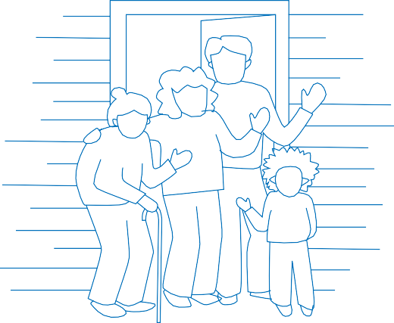


The distribution of more than $675 billion in federal funds, grants and support to states, counties and communities are based on census data.
That money is spent on schools, hospitals, roads, public works and other vital programs.

Taking part is your civic duty.
Completing the census is mandatory: it’s a way to participate in our democracy and say “I COUNT!”

Census data are being
used all around you.

Businesses use census data to decide where to build factories, offices and stores, which create jobs.

Local governments use the census for public safety and emergency preparedness.

Residents use the census to support community initiatives involving legislation, quality-of-life and consumer advocacy.

Your data is confidential.
The law requires the Census Bureau to keep your information confidential and only use it for statistical research.

We will never share your information with immigration enforcement agencies like ICE, law enforcement agencies like the FBI or police, or allow it to be used to determine your eligibility for government benefits.

Real estate developers use the census to build new homes and revitalize old neighborhoods.

2020 will be easier than ever.
In 2020, you will be able to respond to the census online.














You can help.
You are the expert—we need your ideas on the best way to make sure everyone in your community gets counted.

FIND OUT HO W T O HELP AT CENSU S.GO V/PAR TNER S

This is a beta toolkit and is designed to be an ongoing resource for partners and stakeholders.

We welcome feedback, suggestions, and any ideas to help improve the
content. Success stories and potential case studies are welcome too!
Get in touch at census.partners@census.gov and check out
www.census.gov/partners for more ways to get involved.

Find all five toolkit modules at www.census.gov/partners/toolkits
- OVERVIEW: What is a Census Solutions Workshop
- LOGISTICS: How to host a Census Solutions Workshop
- ACTIVITIES: What to do at a Census Solutions Workshop
- CASE STUDIES: What we’ve learned so far
- RESOURCES: Checklists, worksheets, and presentations

Created by
Census Open Innovation Labs
U.S. Census Bureau

PRE-DECISIONAL DOCUMENT

